

battle of the neighborhoods

IBM Data Science Capstone Project

**Sarah Bin saddik**

July , 2020



1. **Inroducution**

1.1 Background:

The capital of Saudi Arabia.

With a population of 7.3 millions, Riyadh is the capital of Saudi Arabia and the largest city on the [Arabian Peninsula](https://en.wikipedia.org/wiki/Arabian_Peninsula).  Riyadh is becoming a leading and an attractive city for tourists and entrepreneurs.

Many citiziens of the capital city spend their time nowadays in Resaurants and cafes, specially that we are having many squares or venues that offer both good site places, high quality local, and franchised restaurants and cafés.

For entrepreneurs investing and opening speciality cafes and restaurants would be a great opportunity for them, specially after opening doors for forign investors to invest in Saudi Arabia.

1.2 Problem :

Having a big city like Riyadh, We are aiming to find the best neighbourhood to open a shop specialized in desserts and unique coffee.

So we are choosing two neighborhoods in the capital of saudi Arabia where hundreds, even thousands of people visit everyday.

As a university student, I can see that we spend most of our time near collage, wether we are studying, doing projects or having fun during our breaks.

So I chose to compare two neighborhoods where two of the largest universities of Riyadh are located.

1.3 Target Audience:

This report can help entrepreneurs who are looking to open a coffee shop near one of two largest Universities in Riyadh, Saudi Arabia.

1. **Data :**

2.1 Data description :

Ill briefly speak about the two universities I have chosen as my main locations.

**King Saud University:**

Founded in 1957, King Saud University is a non-profit public higher education institution. Officially accredited and recognized by the Ministry of Education, Saudi Arabia. King Saud University (KSU) offers courses and programs leading to officially recognized higher education degrees such as pre-bachelor degrees (i.e. certificates, diplomas, associate or foundation degrees), bachelor degrees, master degrees, doctorate degrees in several areas of study.

In addition to scholarship and research, King Saud University provides health and social services to the entire Saudi community, as extending and expanding such services are an essential component of KSU’s comprehensive development plans.

Free health services, vital to any society, are offered by [King Khalid University Hospital (KKUH)](http://medicine.ksu.edu.sa/en/node/371), which possesses highly qualified consultants, carefully chosen physicians, and the finest nursing staff and general personnel possible.

**Al Imam Mohammed Ibn Saud University:**

Founded in 1974, Al-Imam Muhammad Ibn Saud Islamic University is a non-profit public higher education institution located in the urban setting of the metropolis of Riyadh. Al-Imam Muhammad Ibn Saud Islamic University (IMAMU) is a very large coeducational higher education institution formally affiliated with the Islamic religion. Al-Imam Muhammad Ibn Saud Islamic University (IMAMU) offers courses and programs leading to officially recognized higher education degrees such as pre-bachelor degrees (i.e. certificates, diplomas, associate or foundation degrees), bachelor degrees, master degrees, doctorate degrees in several areas of study.

Foursquare API :

I’ll be using the Foursquare API to explore the nearby venues for both King Saud University (KSU) and Imam Mohammed Ibn Saud University( IMAMU) in order to find the most accurate place to open the Shop. I looked for venues up to 4 KM range from the latitude and longitude of both universities.

From the foursquare API, I'll be retriving the following for each nearby venue:

- Name

- Category

- Latitude

- Longitude

1. **Methodology:**

First, to start working in the project, we needed to choose the main location we want to compare between, so as mentioned we chose, King Saud University and Al Imam Mohammed Ibn Saud University. To get the coordinates I used the main universities sites to get them, so I wrote them manually.

To be able to use foursquare API and look for the nearby venues we had to creat a foursquare developer account in order to have a personal API key.

We can get the name, category, latitude and longitude of the venue using the API, I can also see the unique categories we have from the data we got.

To start exploring the nearby venues, we have put radius as 4000 meters ( 4 KM) around the main venues. And a limit of 100 venues so it can be easy to deal with and compare.

After getting the nearby venues, I wanted to see the unique categories we have near the two universities. To be able to filter the kind of venues we are looking for.

1. **Results:**

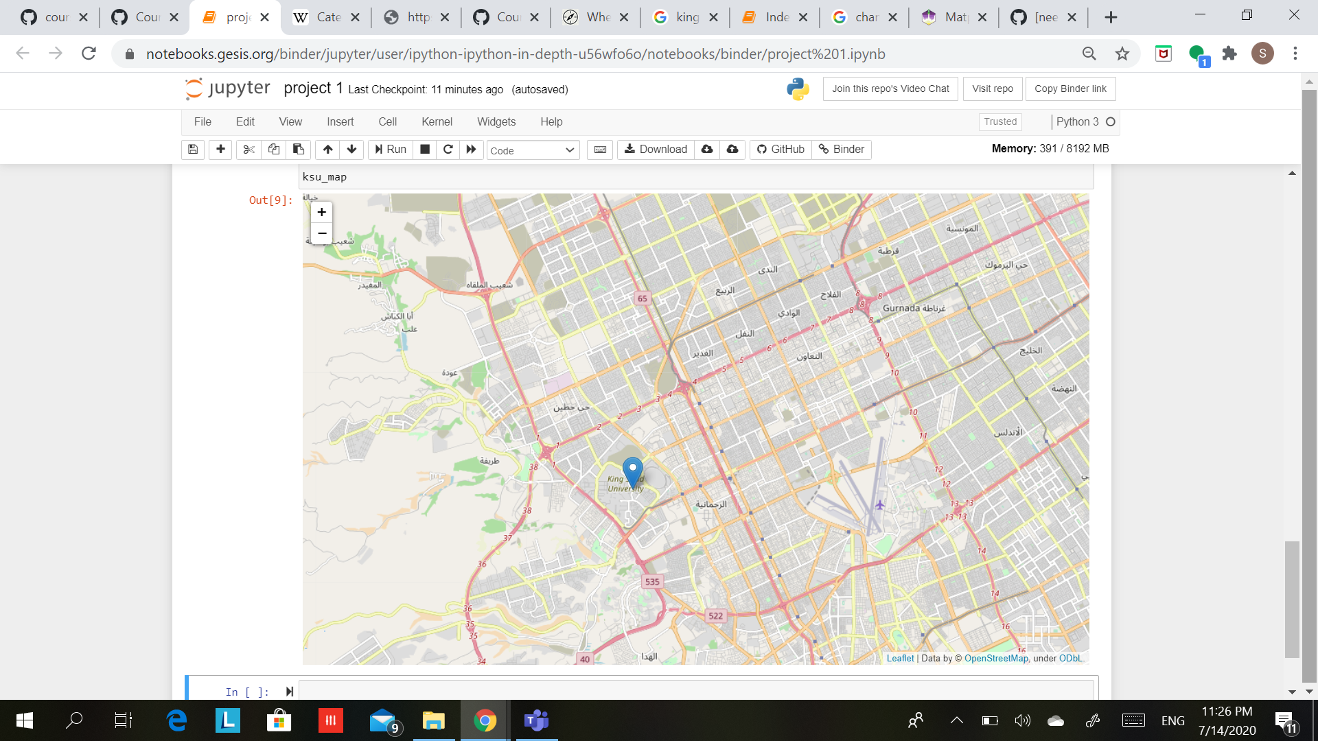

Folium map which shows the location of King Saud University

Folium map which shows the location of Al Imam Mohammed Ibn Saud University

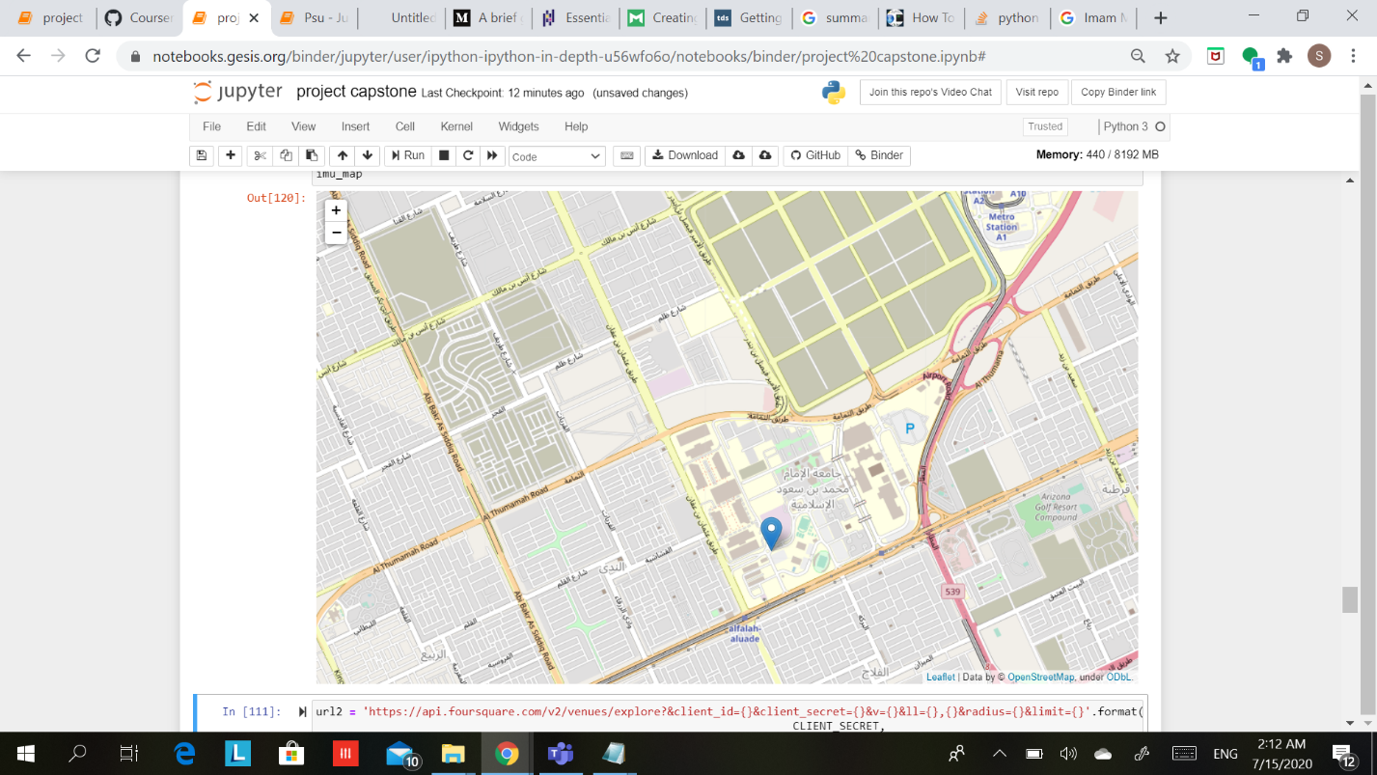

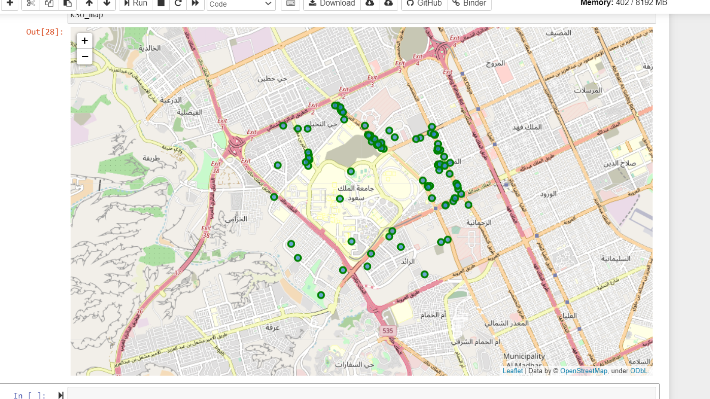

We have the following lists of venues:

King Saud University

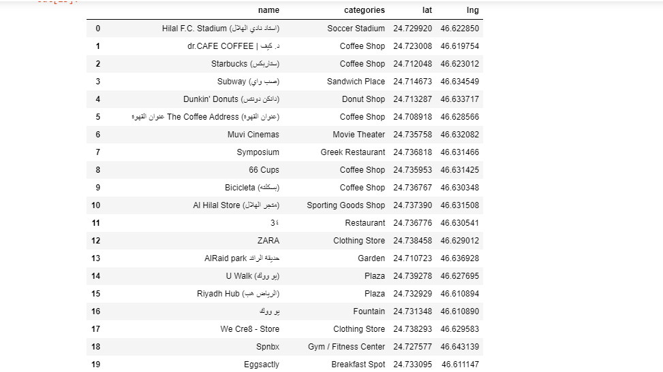

Al Imam Mohammed Ibn Saud University

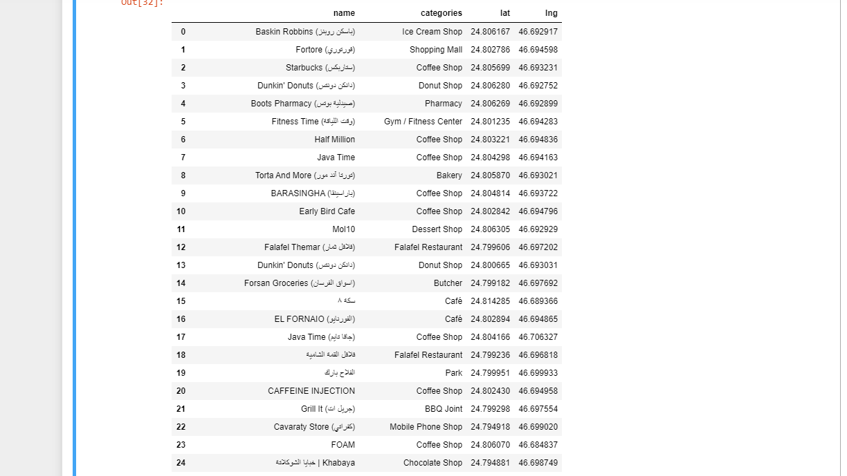

We put the categories in a separate data frame to be able to visualize them in a bar chart.

**King Saud University**

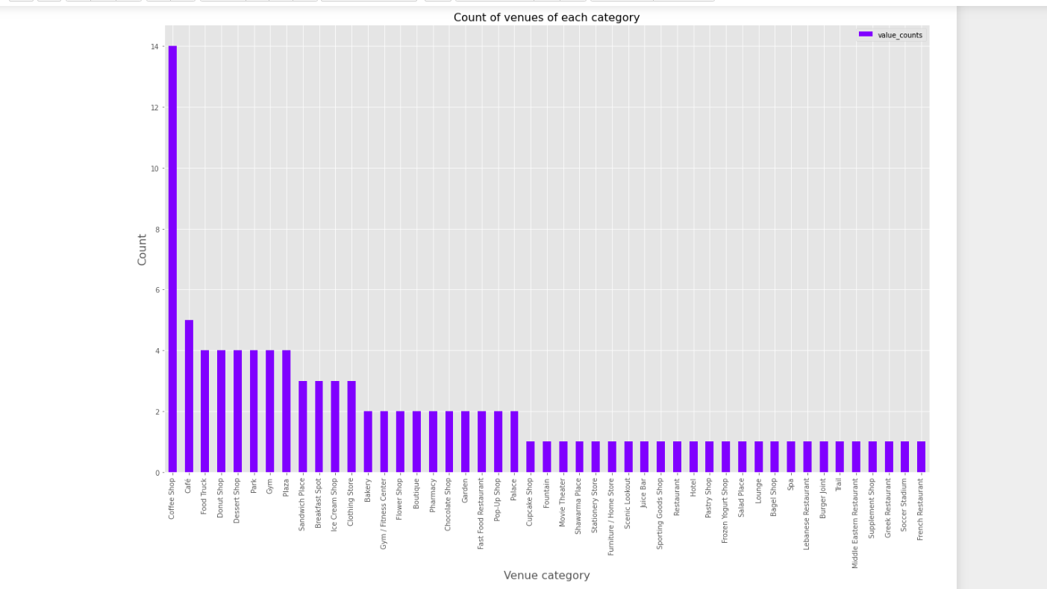

**Al Imam Mohammed Ibn Saud University**

As we see above, coffee shop is the highest category for both neighborhoods, and is its number is way haigher than other categories. We can see that there are coffee shops category and Café category, but I am going to treat them as one, as they both serve coffee.

**King Saud University**

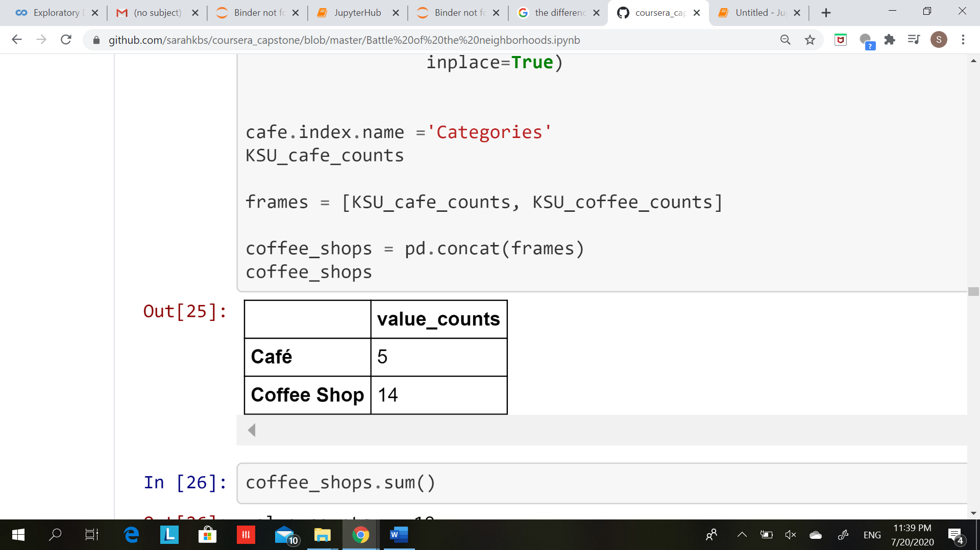

**Al Imam Mohammed Ibn Saud University**

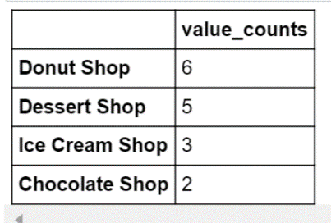

We can see both neighborhoods have a high number of coffee shops, but we can say that opening a shop specialized in coffee and dessert in the first neighborhood ( Near King Saud University ) might be the better option that’s because, Imam University has almost 10 more coffee shops. Although both neighborhoods have the same number of dessert shops.

We can say that the reason behind having a higher number near Imam Mohammed Ibn Saud University is because, is an older residental area, people recently started moving to the north side of Riyadh near KSU.

As for the Restaurants both Areas have low number of Resturants, 7 or 12 are not considered a high numbers in such areas where a high number of employees and students visit everyday. So this also might be a great oppurtunity for enterpanuers.

**Conclusion :**

We have applied some simple comparison techniques to see the better place to open a shop specialized in coffee and desserts , but there is always a place for improvement and taking more factors in consideration such as, rates, prices and tips.

**Resources :**

<https://www.4icu.org/sa/riyadh/>

<https://ksu.edu.sa/en/about-ksu>